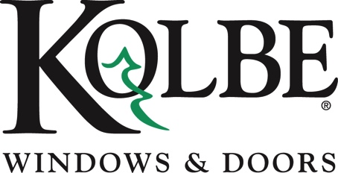

*Media contact: Heather West, 612-724-8760, heather@heatherwestpr.com*

**Kolbe partners with Pawport to integrate Smart Pet Doors**

**into future offerings**

Wausau, Wisconsin (Feb. 2025) – Kolbe Windows & Doors announces its partnership with Pawport to offer The Ultimate System—a smart, secure pet door solution—as a pre-installed option coming to select Kolbe products in the near future. This collaboration will bring homeowners with pets a seamless, automated access solution to the outdoors, enhancing security, convenience and innovation.

The Ultimate System includes the Pawport Smart Pet Door, which uses Bluetooth technology to grant pets secure, personalized access. The system recognizes each pet’s unique collar tag, ensuring that only authorized pets can use the door, while the door can be remotely controlled via a smartphone app for added convenience.

The Ultimate System also features a sturdy tunnel and frame system, paired with a weatherproof Outdoor Pet Door for secure access in all conditions. The system operates in tandem, offering both pets and homeowners effortless operation while maintaining the highest levels of safety and aesthetics. The system’s versatile design allows it to be installed either within a door panel or directly in a piece of glass, making it easy to incorporate into any room of the home.

“We’re thrilled to partner with Pawport to bring this innovative solution to our customers,” said Jeff DeLonay, president of Kolbe Windows & Doors. “The Ultimate System is the perfect combination of security, convenience and design for pet-loving homeowners.”

The Ultimate System will be available in three sizes, various colors and with additional accessories to suit a variety of home and pet needs upon launch.

To learn more about Kolbe’s products and options, please visit <https://www.kolbewindows.com>.

*What began in 1946 as a* [*two-brother team*](https://www.kolbewindows.com/our-story) *has grown into an internationally respected manufacturing company. Kolbe Windows & Doors is one of the nation’s leading manufacturers of* [*windows and doors*](https://www.kolbewindows.com/product-lines) *for residential and* [*commercial*](https://www.kolbewindows.com/solutions/commercial-buildings) *markets. After 75 years, Kolbe products are best known for superior quality, custom* [*craftsmanship*](https://www.kolbewindows.com/solutions/craftsmanship)*, attention to detail, as well as innovative and unique designs.*

*###*