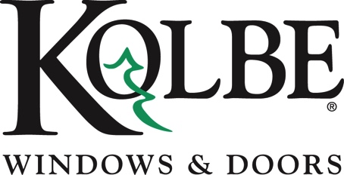

*Media contact: Heather West, 612-724-8760, heather@heatherwestpr.com*

**New Solar Panel System Highlights Energy Efficiency at Kolbe**

Wausau, Wisconsin (April 22, 2025) – Kolbe Windows & Doors recently completed and activated a significant solar panel system on the roof of its main manufacturing facility in Wausau, Wisconsin. This 999.6-kilowatt (kW) alternative energy system, consisting of 2,061 photovoltaic panels, is expected to offset 31.8% of the plant’s current energy consumption.

Kolbe worked closely with Northwind Solar located in Amherst, Wisconsin, on the design and installation of the system**.** The innovative double-sided design of the panels allows them to capture sunlight even after snowfall by gathering reflected light through the underside of the panel. The installation began in 2024 and was partially funded by a USDA Rural Development grant as part of the Rural Energy for America Program (REAP).

“We are thrilled to be utilizing the unused space on the roof of our facility for something so impactful: increasing our operational efficiencies and reducing our carbon footprint,” said Kolbe Windows & Doors president, Jeff DeLonay. “This project represents a major part of our efforts to better serving our team, our community and our environment.”

Additionally, in 2022, Kolbe installed a smaller 19.72-kW, 58-panel solar configuration on the roof of its Innovation Greenhouse, also located in Wausau.

Kolbe’s commitment to energy efficiency extends beyond the solar panel system. The company has implemented several initiatives, including the installation of timer-controlled LED high bay lights, an optimized humidification system and air make-up units (AMUs) to enhance energy efficiency.

To learn more about Kolbe please visit <https://www.kolbewindows.com/our-story>

*What began in 1946 as a* [*two-brother team*](https://www.kolbewindows.com/our-story) *has grown into an internationally respected manufacturing company. Kolbe Windows & Doors is one of the nation’s leading manufacturers of* [*windows and doors*](https://www.kolbewindows.com/product-lines) *for residential and* [*commercial*](https://www.kolbewindows.com/solutions/commercial-buildings) *markets. After 75 years, Kolbe products are best known for superior quality, custom* [*craftsmanship*](https://www.kolbewindows.com/solutions/craftsmanship)*, attention to detail, as well as innovative and unique designs.*

*###*