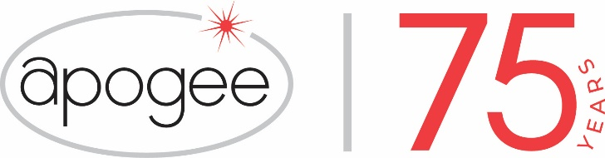

*Media contact: Heather West, 612-724-8760, heather@heatherwestpr.com*

**Apogee Enterprises, Inc. celebrates its 75th Anniversary**

Minneapolis (July 2024) – Apogee Enterprises, Inc. is celebrating its 75th anniversary across its locations and brands – Alumicor™, EFCO®, Harmon®, Linetec®, Tru Vue®, Tubelite®, Viracon®, and GlassecViracon. The company has built a record of growth and innovation, emerging as an industry leading supplier of architectural products and services.

Founded as the Harmon Glass Company on July 12, 1949, the company began with a single shop in Minneapolis. Today, Apogee operates 15 principal facilities with 4,400 employees, led by CEO Ty Silberhorn.

From massive skyscrapers to specialty medical clinics, schools and other building across the world, Apogee’s ideas, innovations and installation add value, enhance aesthetics and ensure performance. These contributions help to improve energy efficiency and resilience for properties, and provide greater safety, comfort, and wellness for occupants.

"Seventy-five years is a remarkable milestone that few companies achieve and speaks to the resilience, ingenuity and innovation of the people that have built our company,” said Ty R. Silberhorn, Apogee’s chief executive officer. “I’d like to extend my thanks to all of Apogee’s employees, past and present, who have contributed to our company’s success over the years.”

Silberhorn continued, “Throughout its history, our company has reinvented itself several times by innovating our business model and offerings to adapt to the changing market. While we take great pride in our history, we’re just as excited about what the future holds for Apogee. We are strengthening our operations, improving our products and service for customers, and investing to strengthen our team and grow our business. I look forward to working with our employees, customers, and shareholders to write the next chapter in our company’s story.”

Initially, Harmon replaced windshields for used car dealers and then began offering contract glass installation for buildings in 1955. Throughout the 1960s, the company expanded into multiple business lines. To coordinate the activities of its subsidiaries, Apogee Enterprises, Inc. was formed in 1968. Later that year, it acquired a manufacturer of aluminum-framed windows in Wausau, Wisconsin, which would become the foundation for the company’s Architectural Framing Systems business. In 1969, Apogee also invested in starting a glass fabrication business, Viracon.

*(more)*

In 1971, Apogee became a publicly traded company, listing shares on the Nasdaq Over-the-Counter exchange. It has continued to grow through acquisitions and organic growth investments, reaching a record $1.4 billion in sales in 2023.

Throughout the years, Apogee’s businesses and brands have frequently been recognized for their innovation and success. In February 2024, *USGlass Magazine*’s Top 50 ranked Harmon as the #1 largest contract glazier. The [Viracon](https://www.viracon.com/) brand is recognized as an industry-leading architectural glass fabricator. Architectural Framing Systems brands, [Alumicor](https://alumicor.com/), [EFCO](https://www.efcocorp.com/), [Linetec](https://linetec.com/) and [Tubelite](https://tubeliteusa.com/) set the standard for quality, reliability and customer service, and the [Tru Vue](https://tru-vue.com/) brand is a leading provider of optical coatings for glass and acrylic.

*Learn more about Apogee Enterprises, its brands and its history at* [*https://www.apog.com*](https://www.apog.com)*.*

###