AIA Booth #3717/Learning Lounge #3625LL
Valspar celebrates 50 years of Fluropon®,
the first 70% PVDF architectural coating in the industry
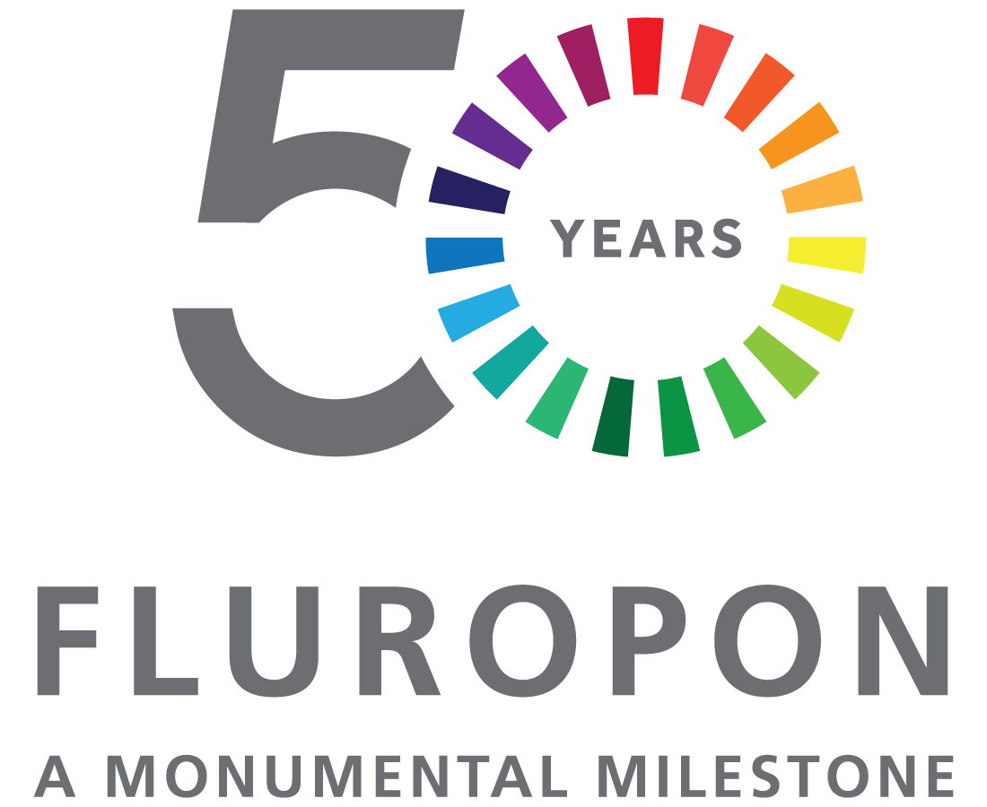
Minneapolis – [March 2015] – The Valspar Corporation celebrates 50 years of Fluropon® 70 percent PVDF resin-based coatings. Since the flagship architectural coating launched in 1965, Valspar’s Fluropon exterior coatings have become the industry standard for both metal coil coating and aluminum extrusion applications.
To commemorate its golden anniversary, Fluropon50.com will provide information on Fluropon products and specifications, BIM content, blog posts and other news to celebrate Fluropon’s 50th year. Valspar also will share notable projects showcasing Fluropon throughout the decades: Aspen Art Museum, 2014; Dubai International Airport in the United Arab Emirates, 2011; Guthrie Theatre in Minneapolis, 2006, Taipei 101 in Taiwan, 2004; Globe Life Park, home of the Texas Rangers, 1994; Tokyo Dome Stadium, 1985; GM Renaissance Center in Detroit, 1977; and the Watergate Towers in D.C., 1971.
Valspar’s John Kelly remembers it all. President Dwight Eisenhower was in the White House and Kelly was 17-years-old in Philadelphia when he started working in the coatings industry. Today, more than 50 years after mixing his first batch of paint, he serves as Valspar’s market manager for metal buildings. “It’s been exciting to be involved with a product whose first response was ‘What is this stuff?’ to one that became the basis of fluoropolymer specifications as used by architects all over the world today,” says Kelly.
In 1965, Pennwalt’s corporate headquarters in Philadelphia was the first project to feature Fluropon commercially. The building was brown, one of only five colors available at the time. Today, there are more than 50,000 active code offerings from neutral to bright colors, micas, metallics and pearlescent coatings.
With its high durability and large color palette, these field-proven, high-performance, 70 percent PVDF resin-based coatings are offered in two- to four-coat systems in nearly any formulation, including low gloss, low sheen and solar reflective ENERGY STAR. Meeting the American Architectural Manufacturers Association’s AAMA 2605 high-performance exterior specification, Fluropon demonstrates reliable performance including resistance to harmful ultraviolet rays, chemical degradation, abrasion and humidity.
Along with its high-performance coatings, The Valspar Corporation supports architects and designers with its industry-leading technical expertise, color-matching and sustainability resources, responsive customer service and high-priority lead times. Learn more at www.valsparinspireme.com.
# # #

Media Contact:  Heather West  612.724.8760  heather@heatherwestpr.com | Media Contact:  Isabel Bartig  612.851.7282  ibartig@valspar.com

About The Valspar Corporation
The Valspar Corporation (NYSE: VAL) is a global leader in the paint and coatings industry. Since 1806, Valspar has been dedicated to bringing customers the latest innovations, the finest quality and the best customer service in the coatings industry. For more information, visit www.valsparglobal.com.

