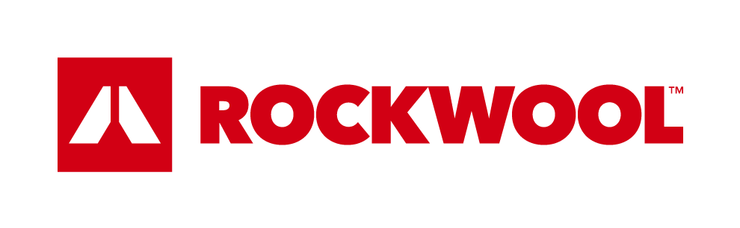

For immediate release

ROCKWOOL® unveils new global brand identity to be adopted throughout North America

April 4, 2017 - ROCKWOOL, the world’s largest producer of stone wool insulation, has officially announced the latest evolution of its brand identity, introducing a new ROCKWOOL symbol and purpose statement that will be adopted by its subsidiary brands in North America. The brand evolution ensures a cohesive look and messaging across all brands, while supporting future geographic growth across all business units.

Brands under the ROCKWOOL umbrella in North America include Roxul®, offering high-performing insulation solutions for building and industrial applications, Grodan®, a leader in progressive and sustainable substrate solutions for professional growers, and Rockfon®, trusted provider of acoustic stone wool and metal ceiling solutions and suspension systems.

Reflecting their synergy in offering advanced stone wool innovations that address local and global issues surrounding sustainability and development, Roxul, Grodan and Rockfon will collectively adopt the new ROCKWOOL symbol––a graphic representation of a volcano that demonstrates to stakeholders and customers how ROCKWOOL brands use the natural power of volcanic stone to enrich and transform modern living, while providing solutions with far-reaching benefits.

The new brand identity will be complemented by a revamped purpose statement, “release the natural power of stone to enrich modern living,” which underscores that all businesses within the ROCKWOOL Group have one overarching goal: to enhance modern living by improving the lives of everyone who comes into contact with ROCKWOOL products.

To view ROCKWOOL’s corporate video featuring the new branding, click HERE.

“We fully embrace the new branding,” says Harold Van Gool, Business Director, Grodan North America “We are proud to convey that all brands belonging to the ROCKWOOL family are connected and steadfast in our shared benefits and values.”

“We want our customers to see us as more than manufacturers,” says John Medio, Managing Director, Rockfon, North America “Our brand refresh and new purpose statement places greater emphasis on why our products exist--to provide solutions that not only change our world for the better, but that also improve daily living for people everywhere.”

“We feel strongly that a more sustainable future is possible, and we want to inspire current and future generations through our leadership,” says Trent Ogilvie, North American President, Roxul Inc. “Whether its insulating, irrigating, purifying, improving safety, energy efficiency or acoustic comfort, our products and processes help people in all corners of the globe to have a more sustainable footprint and combat challenges related to increasing levels of urbanization.”

The new ROCKWOOL symbol will soon be integrated into all Roxul, Grodan and Rockfon products, marketing materials, digital and social channels throughout North America. The new brand identity provides greater information to consumers about the services and solutions they choose, how they are made, and the company that makes them. It underscores a long-held commitment to sustainability, highlighting that all companies under the ROCKWOOL umbrella produce products that come from nature and give back to nature. The brand evolution is more reflective of each company’s shared belief in responsibility to the environment and to society overall.

“The updated brand identity marks an important evolution in the way we talk about our company, conveying a consistent vision and shared heritage across our diverse product portfolio’s full range,” says Mirella Vitale, ROCKWOOL Senior Vice President, Group Marketing, Communications, & Public Affairs.

About the ROCKWOOL Group

At the ROCKWOOL Group, we are committed to enriching the lives of everyone who comes into contact with our products. Our expertise is perfectly suited to tackle many of today’s biggest sustainability and development challenges, from energy consumption to noise pollution and water scarcity to flooding. Our range of products reflects the diversity of the world’s needs, supporting our stakeholders in reducing their own carbon footprint along the way.

Stone wool is a versatile material and forms the basis of all our businesses. With more than 10,500 passionate colleagues in 38 countries, we are the world leader in stone wool solutions, from fire-resistant, high-performing building insulations to acoustic ceilings, forward-designed external cladding systems to horticultural solutions, engineered mineral fibers for industrial use to insulation for the process industry, marine and offshore. For more information, visit: www.rockwool.com.

-30-

For more information, please contact:

Leslie McLaren
NORTH AMERICAN GOVERNMENT AFFAIRS &
CORPORATE COMMUNICATIONS MGR.
Email : leslie.mclaren@roxul.com
Roxul Inc.
8024 Esquesing Line
Milton,Ontario L9T 6W3
Office: (905) 875-9307
Cell: (905) 691-4471
www.roxul.com

